

**SOFTWARE TESTING & AUTOMATION**

**ASSINGMENT  
MODULE-2**

**PREPARED BY : BHARAT V CHAUDHARY**

1. **What is Exploratory Testing?**

Exploratory testing is a concurrent process. Explore the app without referring test cases.

E.g

In Company Environment a testing process run by any experienced employee like Quality Assurance Engineer without developing any test cases behalf of their long time experienced in that field so **its known as exploratory testing.**

1. **What is traceability matrix?**

The Traceability matrix is one type a document that relates to company so the current project requirement is complete or not.

1. **What is Boundary value testing?**

**Th**e Boundary Value Is the testing method of Black Box Testing Where the Tester select a boundary to test.

For E.g

Suppose there are 100 student data available to test so that tester apply this type boundary value method.

Lower Bound Upper Bound

a-1 a a+1 b-1 b b+1

0 1 2 99 100 101

1. **What is Equivalence partitioning testing?**

The Equivalence partitioning Method is the another method of Black Box Testing.

So Tester need to make Equivalence of any entry data and make partition of that data.

So lets take example of it

There are Some Value of 10 to 1000 and check them so here tester can apply Equivalence Partitioning method to check it easily.

Equivalence Representative Result

10 to 100 35,65,99 Pass/valid

101 to 200 105,168,196 Pass/Valid

201 to 300 235,268,292 Pass/Valid

301 to 400 326,365,398 Pass/Valid

401 to 500 411,434,499 Pass/Valid

501 to 600 510,555,594 Pass/Valid

601 to 700 601,655,685 Pass/Valid

701 to 800 701,763,798 Pass/Valid

801 to 900 802,844,899 Pass/Valid

901 to 1000 910,949,1000 Pass/Valid

So that it helps to tester so solve it easy

With this method tester can easily clarify what they need testing and it method is also it saving in time.

1. **What is Integration testing?**

Integration Testing is a level of the software testing process where individual units are combined and tested as a group.

The integration testing is process to check step by step approach to check test data.

E.g sometimes a food supply platform website have many different functionality web-portal like, payment apps and gps tracking apps so that Tester also need to check that other website functionality so that user use it without defect. So the process to **check /test these other website functionality and that food website combine as Group so this called Integration Testing.**

1. **What determines the level of risk?**

The Levels of risk determines by some factors like “a future negative consequences”

1. **What is Alpha testing?**

It is always performed by the developers at the software development site.Alpha Testing is not open to the market and public.It is always performed in **Virtual Environment**. It is always performed within the organization. It comes under the category of both White Box Testing and Black Box Testing.

1. **What is beta testing?**

Beta Testing (field testing) is performed and carried out by users or you can say people at their own locations and site using customer data.

It is only part of BlackBox testing.It is always performed by the customers at their own site.Beta testing can be considered “pre-release” testing.

1. **What is component testing?**

Component Testing is Testing of small component of website.it is also known as unit testing or module testing aslo.

This type of testing can be done by developer when software/product at the developing level.

This is also first stage of validation level.

1. **What is functional system testing?** Functional testing ensures that the requirements or specifications are properly satisfied by the application.It is basically defined as a type of testing which verifies that each function of the software application works in performance with the requirement and specification. This testing is not concerned about the source code of the application. Each functionality of the software application is tested by providing appropriate test input, expecting the output and comparing the actual output with the expected output.
2. **What is Non-Functional Testing?** It is designed to test the readiness of a system.It tests all the aspects which are not tested in functional testing.It is based on expectations of customer.It describes how the product does.

**What is GUI Testing?**

1. Graphical User Interface (GUI) testing is the process of testing the system’s GUI of the System under Test.
2. **What is Adhoc testing?**

Adhoc is informal testing type which aim to break the system and check.This testing is primarily performed if the knowledge of testers in the system under test is very high.

1. **What is load testing?**

Load Testing

Stability + response time + applying load (app will withstand with designed no. of users)

e.g app will handle 1000 users at every 5 sec.

You have to check 1000 or <=1000 users with your app.

1. **What is stress Testing?**

Stability + response time + applying load (app will withstand with designed no. of users)

e.g app will handle 1000 users at every 5 sec.

You have to check 1000 or >=1000 users with your app.

1. **What is white box testing and list the types of white box testing?**

White Box testing is method to finding defect in the system with accessing of code. It is very easy method to finding defects into the system by know of its coding.

Structure-based testing technique is also known as ‘white-box’ or ‘glass-box’ testing technique because here the testers require knowledge of how the software is implemented, how it works.

White box testing is also called glass testing or open box testing. In order to perform white box testing on an application, the tester needs to possess knowledge of the internal working of the code.

Here is Types of White Box testing

1. Statement Coverage: Statement or Segment Coverage is based on only true Conditions.
2. Decision Coverage: Decision or Branch Coverage is covers both True and False Condition.
3. Condition Coverage: Full condition coverage does not guarantee full decision Coverage.

1. **What is black box testing? What are the different black box testing techniques?**

Black Box testing is a functional testing where the testing can be performed without knowledge of internal structure of whole application,

Ex. In mobile phone automatically switch off without reason.

Techniques of Black Box Testing .

There are four specification-based or black-box technique:

Equivalence partitioning

Boundary value analysis

Decision tables

State transition testing

Use-case Testing

Other Black Box Testing

Syntax or Pattern Testing

1. **Mention what are the categories of defects?**

**There are some categories of defect its here**

**Data Quality/Database Defects:** Deals with improper handling of data in the database.

Examples: Values not deleted/inserted into the database properly Improper/wrong/null values inserted in place of the actual values **Critical Functionality Defects:** The occurrence of these bugs hampers the crucial functionality of the application. Examples: - Exceptions **Functionality Defects:** These defects affect the functionality of the application.

Examples:

All JavaScript errors Buttons like Save, Delete, Cancel not performing their intended functions A missing functionality (or) a feature not functioning the way it is intended to Continuous execution of loops

**Security Defects:** Application security defects generally involve improper handling of data sent from the user to the application. These defects are the most severe and given highest priority for a fix.

Examples: Authentication: Accepting an invalid user name/password.

Authorization: Accessibility to pages though permission not given.

**User Interface Defects:** As the name suggests, the bugs deal with problems related to UI are usually considered less severe.

Examples:

Improper error/warning/UI messages

Spelling mistakes

Alignment problems

1. **Mention what big-bang testing is?**

In Big Bang integration testing all components or modules is integrated simultaneously, after which everything is tested as a whole.

Big Bang testing has the advantage that everything is finished before integration testing starts.

The major disadvantage is that in general it is time consuming and difficult to trace the cause of failures because of this late integration.

Here all component are integrated together at once, and then tested.

1. **What is the purpose of exit criteria?**

The Exit criteria of testing stands for the tester know when to stop testing.

Here is some points to know when tester need to stop testing.

1. project is run out of time.
2. Project is run out of budget.
3. All defects are find and fixed.
4. When project owner tell to stop testing.
5. **When should "Regression Testing" be performed?**

The Regression Testing can be performed

Regression testing is nothing but full or partial selection of already executed test cases which are re-executed to ensure existing functionalities work fine.

This testing is done to make sure that new code changes should not have side effects on the existing functionalities. It ensures that old code still works once the new code changes are done.

1. **What is 7 key principles? Explain in detail?**

* **Testing Shows Presences of Defects:** It means when we start to do testing of any project/product so that we find some defects on it. So if we do not test it before purchase/deliver so it is possible to it create a huge negative impact for people or market.
* **Exhaustive Testing Cannot be Possible:** it means QA cannot do advance Testing from any same project.
* **Early Testing :** Testing activities should start as early as possible in the software or system development life cycle, and should be focused on defined objectives.
* **Defects Clustering :** A small number of modules contain most of the defects discovered during pre-release testing, or are responsible for the most operational failures.
* **The Pesticide Paradox:** If the same tests are repeated over and over again, eventually the same set of test cases will no longer find any new defects.
* **Testing is context dependent:** Testing is done differently in different contexts.Different kinds of sites are tested differently.For e.g Safety – critical software is tested differently from an e- commerce
* **Absence Error fallacy:** If the system built is unusable and does not fulfill the user’s needs and expectations then finding and fixing defects does not help.

1. **Difference between QA v/s QC v/s Tester.**

|  |  |  |
| --- | --- | --- |
| Quality Assurance | Quality Control | Testing |
| Activities which ensures the implementation of processes and procedures in context to verification of developed software. | Activities which ensures the verification of developed software with respect to documented requirements. | Activities which ensures the identification of bug/error/defect in the software. |
| Focuses on processes and procedures rather than actual testing. | Focuses on actual testing by executing the developed software | Focuses on actual testing. |
| Process oriented activities | Product oriented activities | Product oriented activities |
| Preventive process | Corrective process | Preventive process |
| Subset of STLC (Software Testing Life Cycle) | Subset of QA. | Subset of QC |

1. **Difference between Smoke and Sanity?**

**Smoke Testing:**

1. Smoke Testing is performed to ascertain check that the critical functionalities of the program is working fine
2. The objective of this testing is to verify stability" of the system in order to with more rigorous testing.
3. This testing is performed by the developers or testers.
4. Smoke testing is usually documented or Scripted.
5. Smoke Testing is usually General health check up.
6. Smoke testing is subset of Acceptance Testing.

**Sanity Testing:**

1. Sanity Testing is done to check the new functionality / bugs have been fixed
2. Sanity testing is usually performed by testers.
3. Sanity Testing is usually not documented pr not scripted.
4. Sanity Testing is Specialized health check up.
5. Sanity Testing is Subset of Regression Testing.
6. **Difference between verification and Validation.**

|  |  |  |
| --- | --- | --- |
| **No** | **Verification** | **Validation** |
| **1** | Verification is a process which is performed at development level | Validation is a process which is performed at testing level |
| **2** | Verification is a static testing.Verification can be achieved by asking “Are you building a product right?” | Validation is a dynamic testing. |
| **3** | Bugs can be found during the process of development | Bugs can only be found after the process of development |
| **4** | It is used to prevent errors. | Validation activity is Testing. |
| **5** | Verification activities are Reviews and Inspections. | Validation can be achieved by asking “Are you building a right product?” |

1. **Explain types of Performance testing.**

Software performance testing is a means of quality assurance (QA). It involves testing software applications to ensure they will perform well under their expected workload.

1. **Load testing :** Load testing evaluates how the system performs under a specific load, which is typically the expected number of users or transactions.
2. **Stress testing :** Stress Testing: Stress testing pushes the system beyond its normal operational limits to evaluate its behavior under extreme conditions.
3. **Endurance testing :** Spike testing is a type of stress testing that involves rapidly increasing the load on the system to test its reaction to sudden, sharp spikes in traffic.
4. **Spike testing :**  Endurance testing, also known as soak testing, evaluates the system's performance over an extended period under a normal load.
5. **Volume testing :** Scalability testing determines the ability of the system to scale up or scale out (i.e., add resources like servers or memory) to handle increased load.
6. **Scalability testing :** Volume testing assesses the system’s ability to handle a large volume of data.

**What is Error, Defect, Bug and filure?**

**ERROR –** it means we found some mistakes in coding its known as error.

**DEFECT –** Error found by Tester its known as Defects.

**BUG -** A defects accepted by Developer its known Bug.

**FAILURE -** A system cannot meet specific requirement its known as failure.

1. **Difference between Priority and Severity**
2. **What is Bug Life Cycle?**

“A computer bug is an error, flaw, mistake, failure, or fault in a computer program that prevents it from working correctly or produces an incorrect result. Bugs arise from mistakes and errors, made by people, in either a program’s source code or its design.”

The duration or time span between the first time defects is found and the time that it is closed successfully, rejected, postponed or deferred is called as ‘Defect Life Cycle’.

When a bug is discovered, it goes through several states and eventually reaches one of the terminal states, where it becomes inactive and closed.

The process by which the defect moves through the life cycle is depicted next slide.

**NEW>**

**ASSINGED>**

**OPEN>**

**FIXED>**

**PENDING>**

**RETEST>**

**VARIFIED>**

**CLOSED>**

1. **Explain the difference between Functional testing and Non Functional testing .**

**Functional Testing =** Functional testing ensures that the requirements or specifications are properly satisfied by the application.It is basically defined as a type of testing which verifies that each function of the software application works in performance with the requirement and specification. This testing is not concerned about the source code of the application. Each functionality of the software application is tested by providing appropriate test input, expecting the output and comparing the actual output with the expected output.

Types of Functional Testing

**1.** [Unit Testing](https://www.geeksforgeeks.org/unit-testing-software-testing/" \t "https://www.geeksforgeeks.org/differences-between-functional-and-non-functional-testing/_blank)  
**2.** [Smoke Testing](https://www.geeksforgeeks.org/smoke-testing-software-testing/" \t "https://www.geeksforgeeks.org/differences-between-functional-and-non-functional-testing/_blank)  
**3.** [Integration Testing](https://www.geeksforgeeks.org/software-engineering-integration-testing/" \t "https://www.geeksforgeeks.org/differences-between-functional-and-non-functional-testing/_blank)  
**4.** [Regression Testing](https://www.geeksforgeeks.org/software-engineering-regression-testing/" \t "https://www.geeksforgeeks.org/differences-between-functional-and-non-functional-testing/_blank)

**Non-Functional Testing =** It is designed to test the readiness of a system.It tests all the aspects which are not tested in functional testing.It is based on expectations of customer.It describes how the product does.

Types of Non-Functional Testing

1. [Performance Testing](https://www.geeksforgeeks.org/performance-testing-software-testing/" \t "https://www.geeksforgeeks.org/differences-between-functional-and-non-functional-testing/_blank)  
   **2.** [Load Testing](https://www.geeksforgeeks.org/software-testing-load-testing/" \t "https://www.geeksforgeeks.org/differences-between-functional-and-non-functional-testing/_blank)  
   **3.** [Stress Testing](https://www.geeksforgeeks.org/stress-testing-software-testing/" \t "https://www.geeksforgeeks.org/differences-between-functional-and-non-functional-testing/_blank)  
   **4.** [Scalability Testing](https://www.geeksforgeeks.org/software-testing-scalability-testing/" \t "https://www.geeksforgeeks.org/differences-between-functional-and-non-functional-testing/_blank)

**What is the difference between the STLC (Software Testing Life Cycle) and SDLC (Software Developing life Cycle).**

|  |  |
| --- | --- |
| **SDLC** | **STLC** |
| SDLC is mainly related to software development | STLC is mainly related to software testing. |
| Besides development other phases like testing is also included. | It focuses only on testing the software. |
| SDLC involves total six phases or steps. | STLC involves only five phases or steps. |
| In SDLC, development team makes the plans and designs based on the requirements | In STLC, testing team(Test plan or Test case development) makes the plans and designs |
| Goal of SDLC is to complete successful development of software. | Goal of STLC is to complete successful Testing of software. |
| It helps in developing good quality software. | It helps in testing the software is defect free or not. |
|  |  |

1. **What is the difference between test scenarios, test cases, and test script?**

|  |  |  |
| --- | --- | --- |
| **Test Scenario** | **Test Case** | **Test Script** |
| Any functionality that can be tested | It involve the set of steps, conditions and inputs which can be used while performing the testing tasks | A set of sequential instruction that detail how to execute a core business function |
| May include multiple test cases | Includes preconditions, steps, and expected results | Written in a programming/scripting language |
| e.g., "Verify user login functionality." | e.g., TC001: Verify login with valid credentials | e.g.,Selenium script for automated login test |
| The scenarios are derived from use cases | Test cases are derived from test scenario | Set of instructions for executing a test case i.e. derived from test case |

**Explain what Test Plan is? What is the information that should be covered.**

A document describing the scope, approach, resources and schedule of intended test activities

* Determining the scope and risks and identifying the objectives of the testing
* Defining the overall approach of testing including test entry and exit criteria
* Integrating and coordinate the testing activities into software life cycle
* Scheduling test analysis, design, implementation, execution and evaluation activities

Test Plan & Strategy, Test Planning Factors, Test Planning Activities, **Entry Criteria, Exit Criteria should be covered in** Test plan

1. **When to used Usablity Testing?**

Aesthetics and design are important. How well a product looks usually determines how well it works

There are many software applications / websites, which miserably fail, once launched, due to following reasons:

Where do I click next?

Which page needs to be navigated?

Which Icon or Jargon represents what?

Error messages are not consistent or effectively displayed

Session time not sufficient

Usability Testing identifies usability errors in the

system early in development cycle and can save a product from failure

e.g.,

In Web Based Testing , Desktop Based , Mobile based & Game based Testing, if fields on a page (Text box, radio options, drop-down lists) aren’t aligned properly, not accessible by keyboard shortcuts then we need usability testing in those cases

In short, effectiveness of the system, efficiency, eccuracy, user friendliness are goals in need of usability testing

1. **What is the procedure for GUI Testing?**

**Procedure for GUI testing involves:**

* **MANUAL BASED TESTING**

Under this approach, graphical screens are checked manually by testers in conformance with the requirements stated in business requirements document

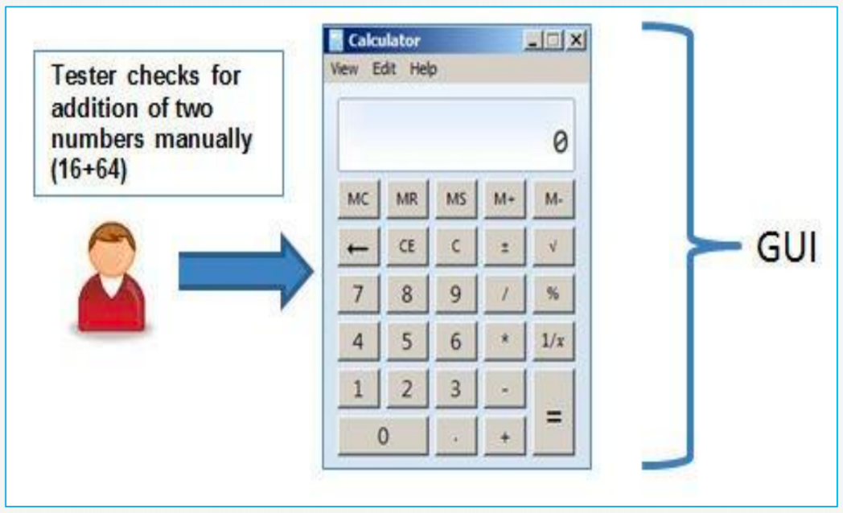

* **RECORD AND REPLAY**

GUI testing can be done using automation tools.

This is done in two parts:

During Record, test steps are captured into the automation tool

During playback, the recorded test steps are executed on the Application under Test. Example of such tools - QTP

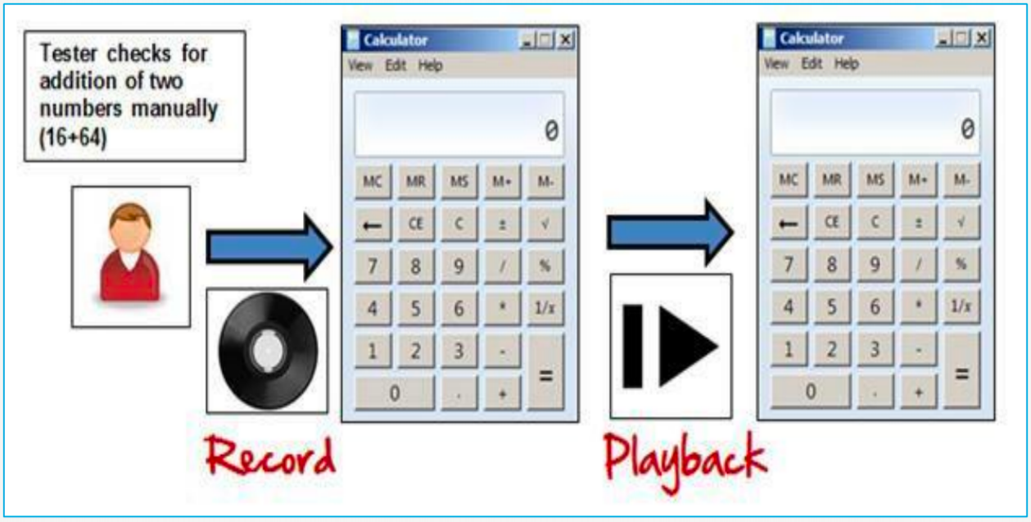

* **MODEL BASED TESTING**

A model is a graphical description of system’s behavior. It helps us to understand and predict the system behavior. Models help in a generation of efficient test cases using the system requirements (e.g. Charts, Decision tables etc)

e.g. Build a model

Determine Inputs for the model

Run the tests

Compare the actual output with the

Expected output

Decision on further action on the model

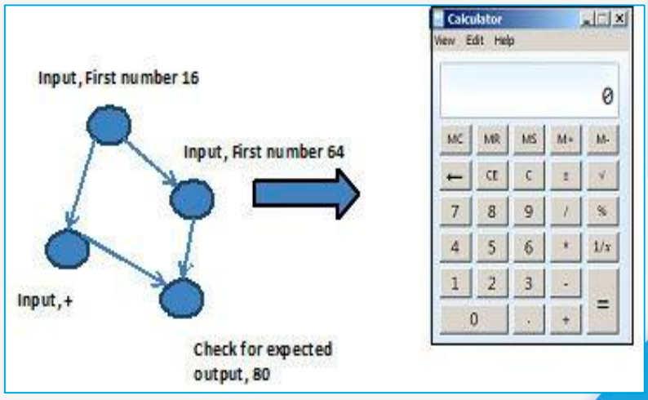

1. **Write test scenarios for real objects (Pen, Pen Stand, Door, ATM, Microwave Owen, Coffee Vending Machine, Chair, Wrist Watch, Lift (Elevator), Water Bottle, Fan)**

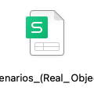

1. **Write test scenarios for apps (Gmail (Receiving mail, Online shopping to buy product (Flipkart), Only Whatsapp chat messages, Whatsapp Group (generate group, Whatsapp payment)**

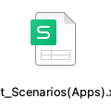

1. **To create HLR, Test Scenario and Test cases on**

Instagram (web) Login Page: <https://www.instagram.com/accounts/login/?hl=en>

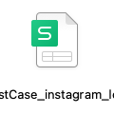

Facebook (web) Login Page: <https://www.facebook.com/>

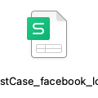

WhatsApp (web): <https://web.whatsapp.com/>

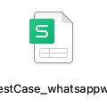

ArtOfTesting Contact us page: https://artoftesting.com/

